**What is modern physics?**

Modern physics is a theory that tries to answer the questions:

1. What is light? Why isn’t there an entire class on this? What experiments could we run to find out what light is? What do we know for certain about light? Did light always exist?
2. What are the smallest pieces of matter that exist? If we keep zooming in on my hand, or my pencil, what is there to see? Cells, parts of the cell, DNA, Molecule (amino acids), Atoms, Quarks, …)

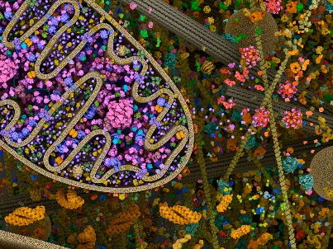

1. Epithelial Cells (ASU)

(2) Computer Animation of Mitochondria

1. We know light is really fast. We know that it contains “energy”. We know every living thing on this planet depends on the Sun’s light.
2. 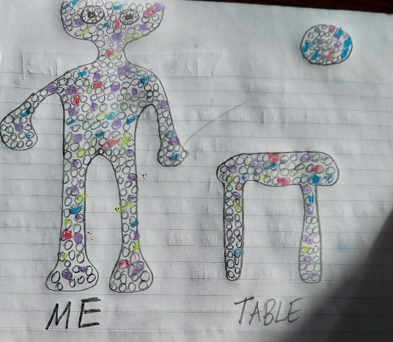I know that everything I can see, the hard chair I am sitting on, my jacket, my fingers, my computer are made up of tiny particles called atoms. Atoms make up everything solid. An atom consists of tinier parts: a proton, neutron, and electron. Has this really been proven?

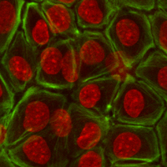What if despite looking and feeling different

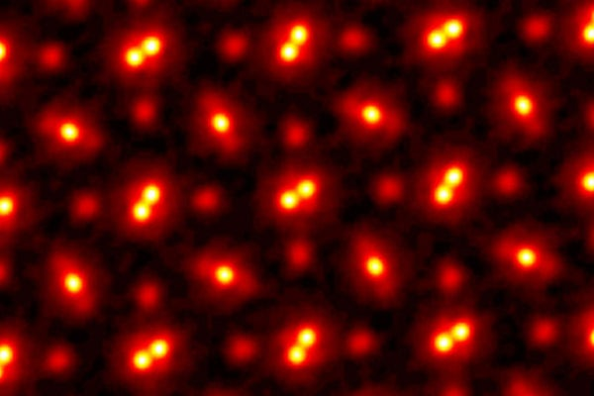I am made of the same thing that the table and sun and water is made up of. If you look close enough, and zoom in close enough to each of us, we will see an atom. The same atom. But this is theoretical. Nobody has actually ever been able to take a picture of an atom. This is the highest resolution picture of an atom ever taken.

(3) Cornell Research Team Fires Electrons at Crystal

The way this image was taking is by firing an electron beam at the atoms in this crystal. Some of the electrons hit head on and bounce back, other go completely through the crystal. The electrons scatter across all directions and hit a detector. Based on where the electrons hit the detector, and “image” of the electrons is reconstructed.

**One explanation of the double-slit experiment** treats things like light, electrons, atoms, and even molecules like waves. It explains the double experiment by saying these things are waves that pass through both slits and interfere with themselves. One can find out how this wave changes over time using an equation that a physicist named Schrodinger came up with as an educated guess.



Somebody made a funny video where he solved the one-dimension Schrodinger equation in a few different scenarios:

(4) Animating Waves to Some Dramatic Music (Carmina Burana)!

I want to animate how the Schrodinger equation predicts an interference pattern in the double slit experiment.

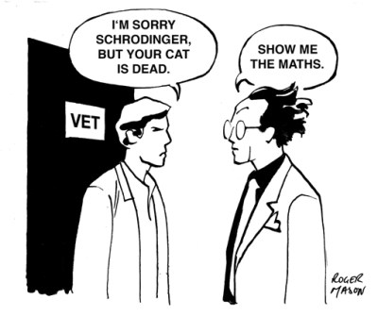There are a few funny cartoons people created about things like the Schrodinger equation. Schrodinger’s cat is the idea that if microscopic objects like an electron when place in a box have an indeterminate properties (existing at multiple locations at the same time), then why can’t cat do the same when you place it into a box, that is be dead and alive at the same time. **That’s a contradiction we have to grapple with if we are going to accept this wave theory.**

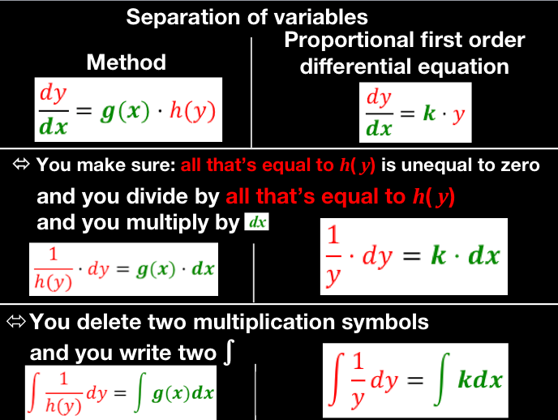One PDE that might be worth looking into is called the **Helmholtz equation**. Apparently it pops up when trying to talk about waves and describe them using a PDE, whether that is light waves or matter waves. This is another PDE that can be solved using separation of variables!



One thing that is absolutely bonkers it that there are still double-slit experiments being conducted, and being used as proof that matter must be a wave, and that Quantum Mechanics can provide a complete description of individual particles. This is the experiment that physicist appeal too when they are trying to make sense of what the mathematical formalism of Quantum Mechanics actually means!

(4) Electron beam goes through a double slit

**Does the wave function exist in physical space?**

(5) Do electrons exist physically as waves in 3D space?

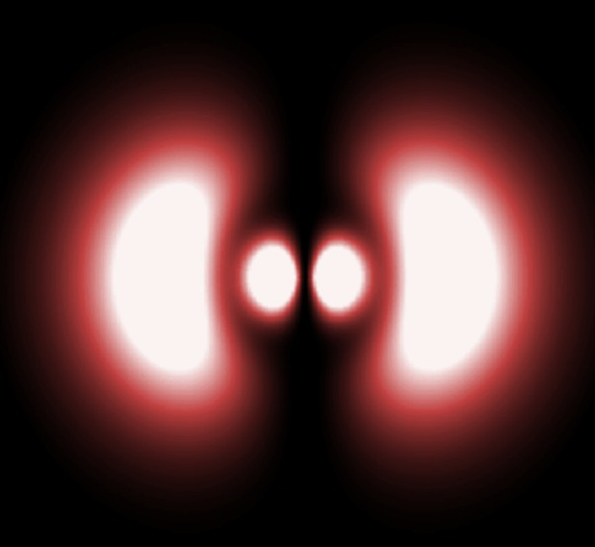[One professor of physics](https://www.wtamu.edu/~cbaird/sq/2014/02/07/what-is-the-shape-of-an-electron/) Christopher Baird claimed that an electron actually *is* a complex-valued wave function” that passes through both slits and does not have a definite location! I can’t remember exactly who this was, just that he went to Brigham Young University. Here I was just a paper about how many mathematical formulations of QM actually exist right now, and how the wave formulation falsely gives impression that the wave function is something that physically exists like a baseball! Instead the wave function is “a mathematical tool for calculating the outcomes of observations, and is not physically present in space such as a football or a molecule”. The author claims that they can modify the wave-function without changing the predictions the wave function gives.



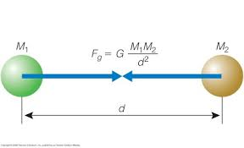In double slit-experiment, we have a pattern, but nobody know where it comes. Just like gravity. We see a pattern, everything that goes up comes right back down. But we have no idea where this comes from. And people have imagined all these exotic things are taking place. But none of theories can definitely answer why things fall to ground. The best theories out there provide predictions, and hopefully insight, an explanation that makes sense to me. It is strange to me how these theories are taught without a face, as if Newton didn’t sit down and write in journal this equation.

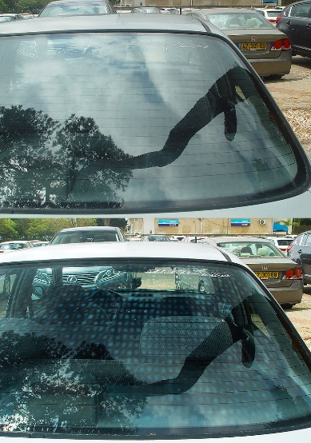It turns out you can slightly modify the double-slit experiment and destroy the “interference” pattern. If you add polarizers to each slit, so that only light that generate vertical electric field can pass through one slit and light that generates horizontal electric field can pass through the other slit, then the inference pattern disappears!

(6) Here a polarizer allows you to see the variations in the car glass clearly. But when covering a double-slit the interference pattern supposedly disappears!

* When light spread out in all directions, that makes some things invisible (glare)
* By only allowing light traveling in a specific direction to pass through, you can get rid of glare! That’s why some people by polarized glasses

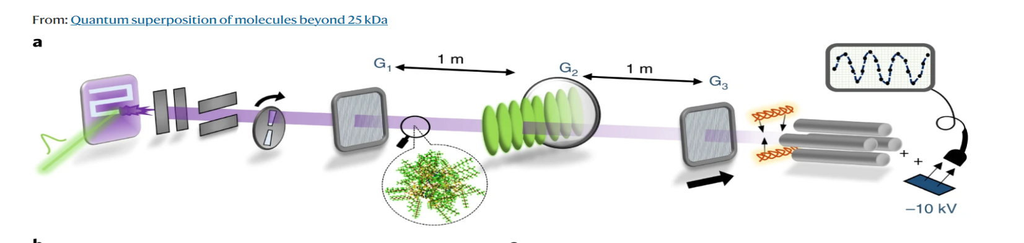Apparently, even huge particles (2000 atom molecules) display interference patterns. A recent experiment in 2019 demonstrated that huge molecule with a de Broglie wavelength is less than the diameter of a hydrogen atom still show interference.

(7) Beam of huge molecules is shot out of a laser and it still creates a interference pattern!

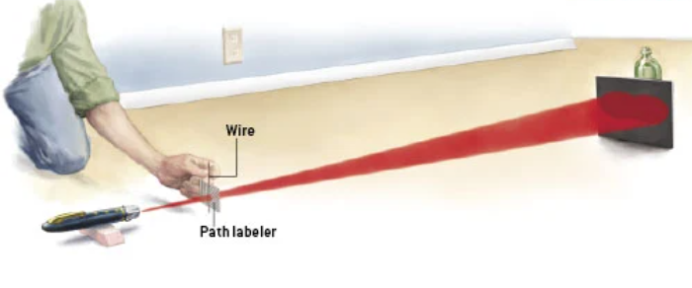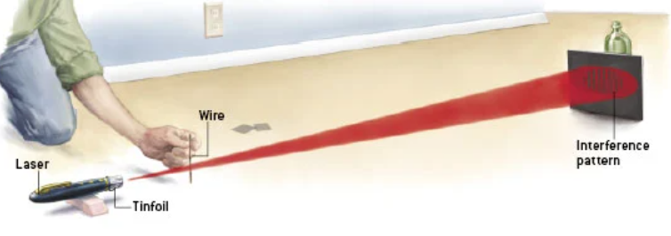Yoo! I just found a do-it yourself quantum eraser experiment. All you need to run the experiment is a laser, a wire, and two polarizers and you can see this weirdness. You shine light across a wire and instead of seeing like two bright spots you seen 10 separated bright spots. Why does that happen? And if you take a polarizer right behind the wire, one the takes only horizontally polarized light and one that takes only vertically polarized light, then interference pattern disappears!

(8) You can destroy the pattern by just polarizing the light that passes through each side!

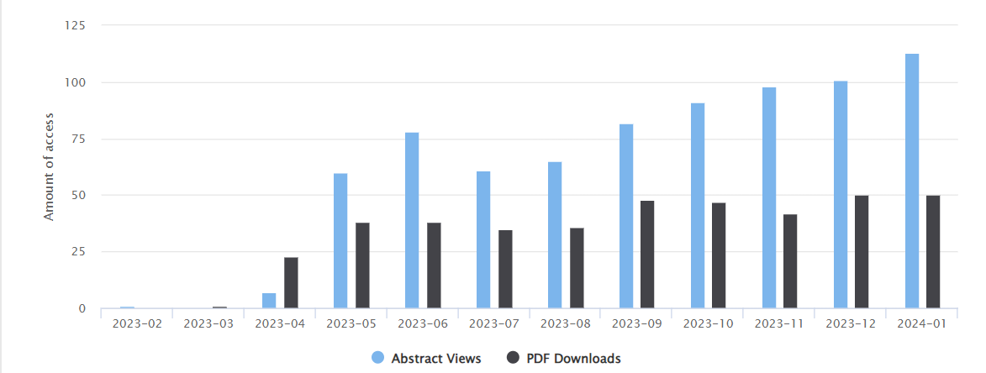**Popular Interest.** There are a lot people who actually care about the double-slit experiment and it’s connection to the Schrodinger Equation! Over 1000 people accessed Glenn’s paper on the subject in the last few months!

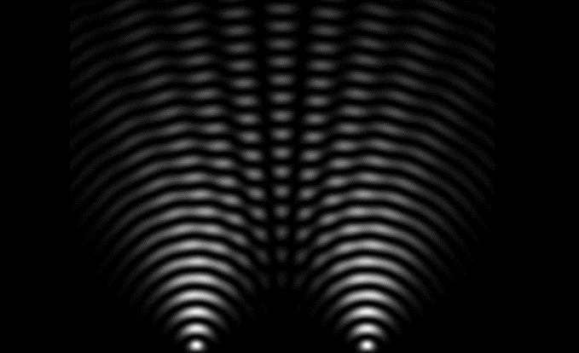**Pilot-Wave Theory.** Is there a good analogy that can explain the double-slit experiment? In 2005, some students at MIT thought they might have been onto a one, describing particles using fluid dynamics. Basically they found that oils droplets on a container of vibrating water could “walk” across the water propelled by their own waves.

Classical particle could never move through two holes at the same time. So what other possibilities are there?

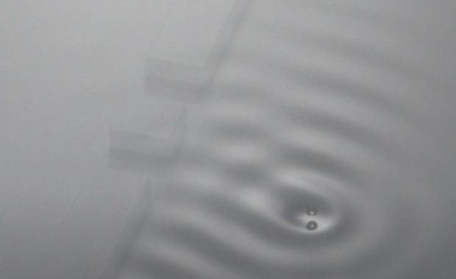Neils Bohr’s grandson is a physicist who studies how fluids move and when this idea came out, maybe because of his family connection and history, but he really inspired to see whether this droplet fluid system could behave identically as particles in the double-slit experiment. Despite the initial claim that it could, further experiment show that this model is not promising. If you extend the length of the slit, Schrodinger solution doesn’t change by the water droplet does.

(9) What if a particle isn't a wave, but instead just moved a wave?

**A Good Analogy.** This pilot wave theory is still being expanded on at MIT, since it is able to “reproduce” some of the behavior of quantum particles. Emerson jotted down in his notebook 100 years ago “Nature Loves Analogies but not Repetitions” in a book education. I think people love analogies too and that’s why this pilot wave theory got people so excited, because when these bouncing oil droplets were able to mimic behavior of quantum particle (diffraction, interference, and teleportation), they had found a good analogy. It is crazy that I just randomly this based off a [link](https://phys.org/news/2010-10-fluid-dynamics-insights-quantum-mechanics.html?utm_source=TrendMD&utm_medium=cpc&utm_campaign=Phys.org_TrendMD_1#nRlv) from Glenn’s paper.

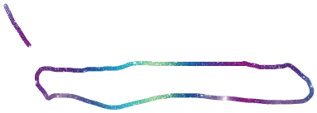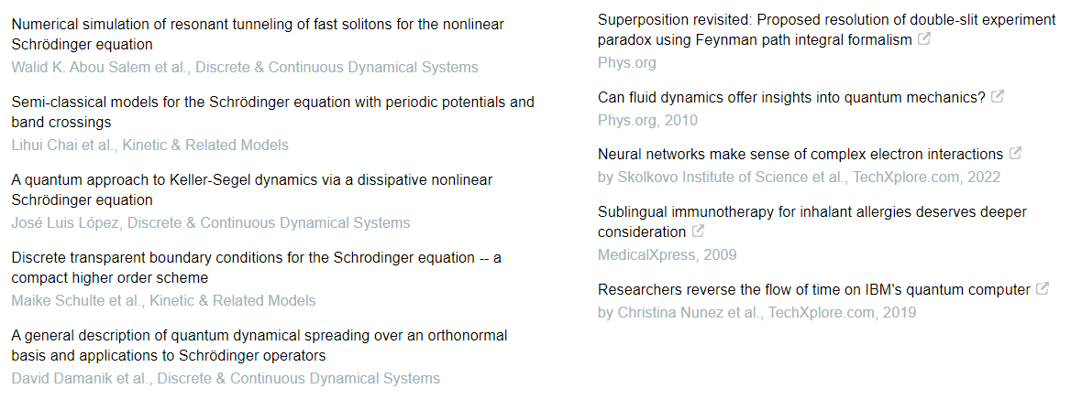

Additional Articles on Glenn's Paper: I only clicked on the one with question (most interesting!)

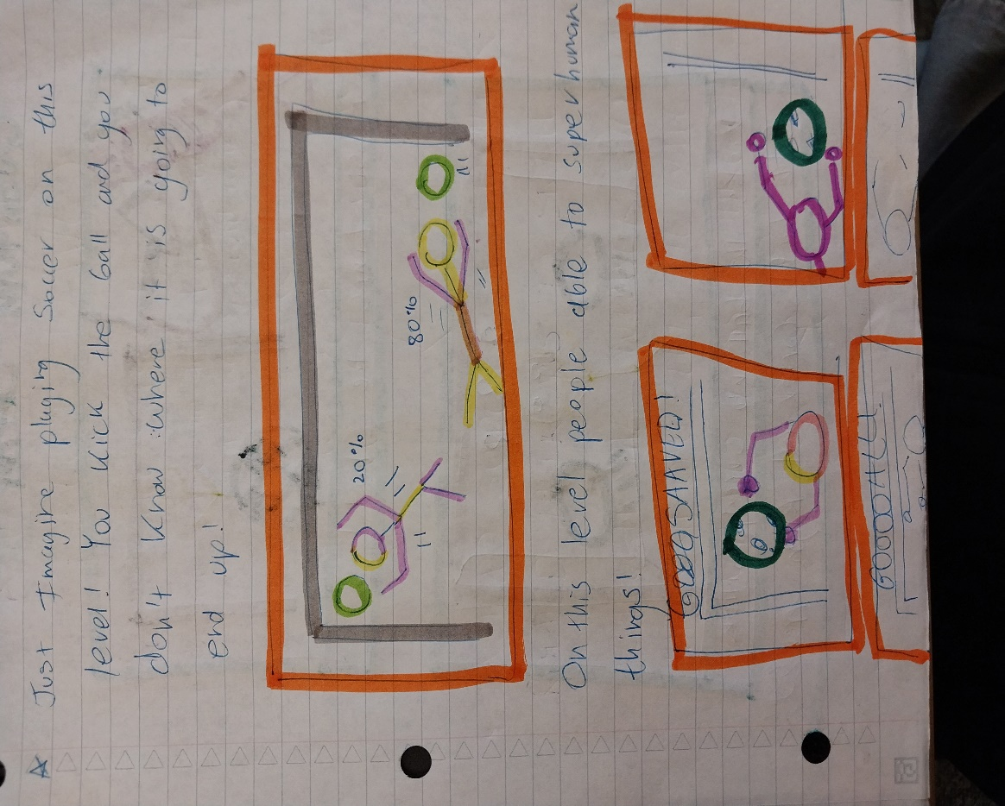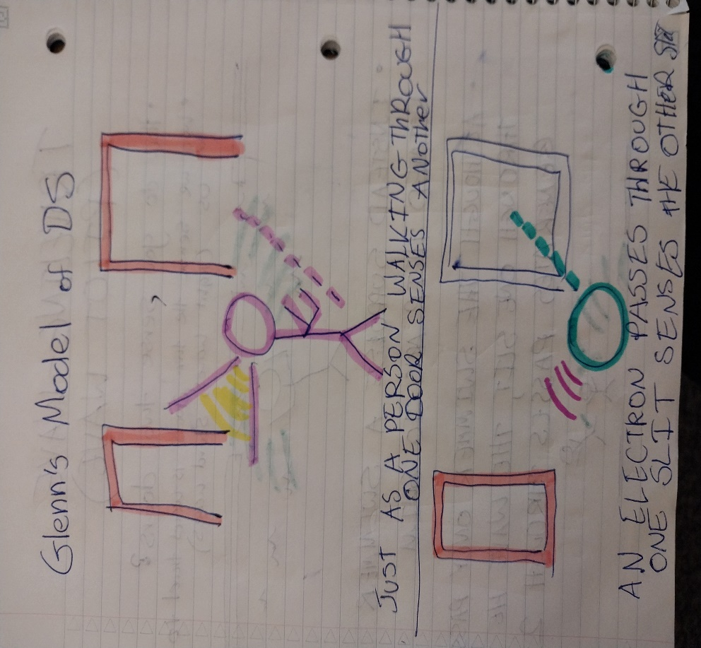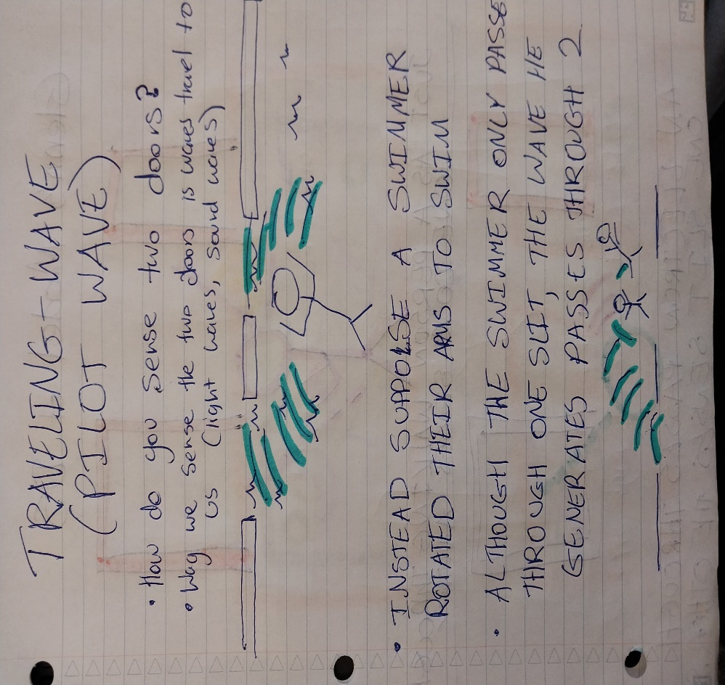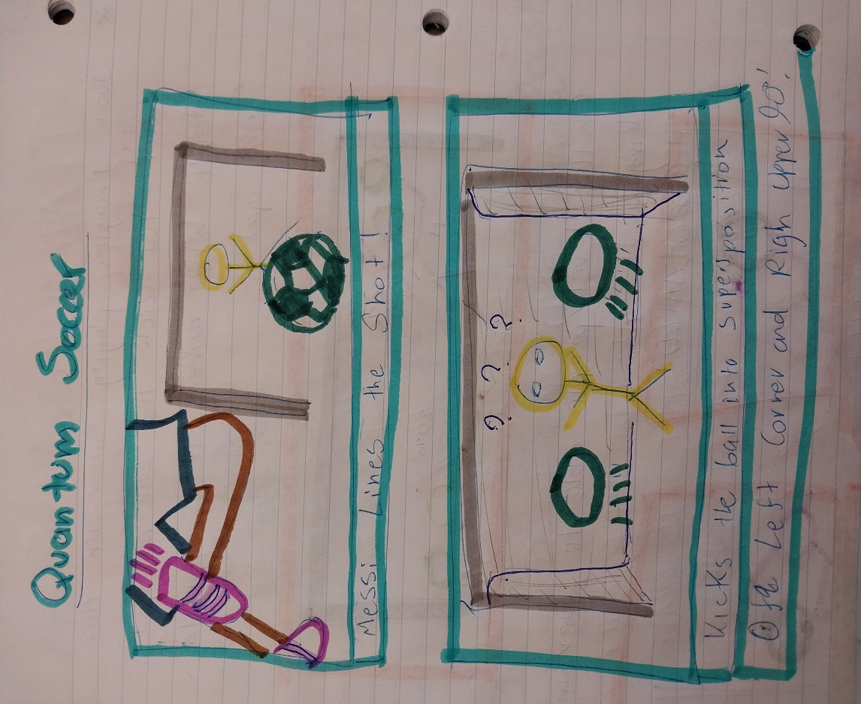

The double-slit phenomenon is a real-life magic trick. And I don’t think physicists have figure out quite yet how nature pulls it off. I am learning this thing for the first time in college, and while many people are used to this, I have no clue how this happens. How does one object pass through two holes at the same time?

* 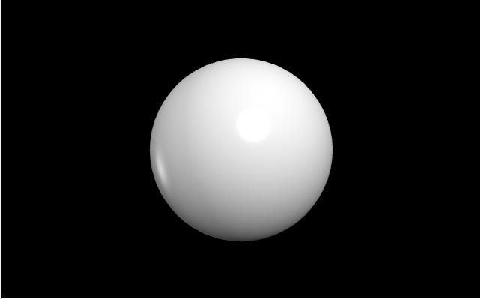No model right now is able to predict where exactly a single photon, electron, or atom, will end up when fired through these slits. Instead what these theories accurately predict is the pattern pops up when many of these particles are fired through the two slits.

In Glenn’s model we are using a diffusion equation. Diffusion is the process by which matter is spread out by the random motion of a fluid it is in. A great example of this is when you add food coloring a glass of water.

Schrodinger Equation is great in some ways, and not so great in others. It’s great computationally:

*“Finding solutions of the Schrödinger Equation for many particle systems is one fundamental problem in Chemistry and Physics” (10)*

gives really good predictions that agree with experiments. But doesn’t seem to give insight into what’s going, why the computation works out? What exactly is the wave function? To me it begs the question, does Quantum mechanics model have to be probabilistic? It appears yes, when we aren’t looking at the particles it seems like they behave in a way that no classical object behaves like. I want to see what other models are out there that do a good job at modeling quantum phenomena!

Now it’s time to stop playing around and do some real physics!

What do I need to run these small double-slit experiments?

A surface with holes to shine light:

1. How far apart should the holes be placed?
2. What material should the slits be made of? Does it matter? What would be ideal?

Something to hold up the surface:

1. Math textbooks
2. Something heavy

A light source:

1. A handheld laser
2. A laser with a stand

Something to detect the light:

1. A piece of film
2. A webcam

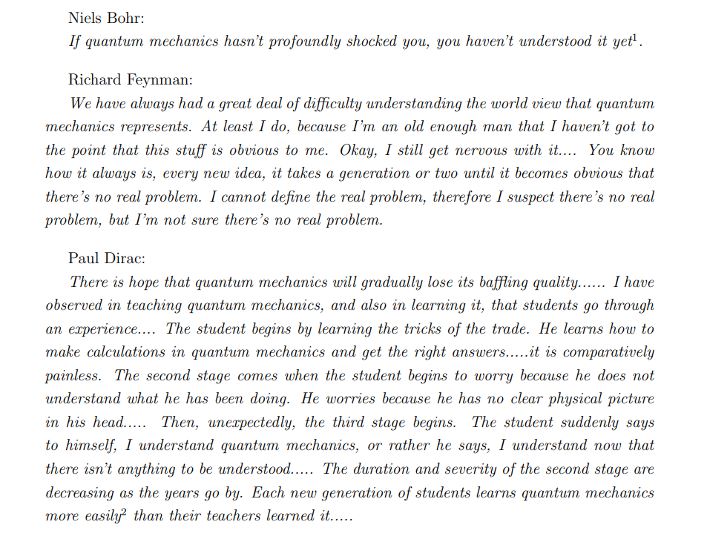****I also want to interview some of the world leading experts on the subject of the two-slit experiment, people who have spent a ton of time thinking about this experiment and exploring what it means. Braine Greene is one of those world leading experts, but he is probably not too accessible. I was just watching one of Briane Greene’s videos on the two-slit experiment and he made it 10-years ago. In the video, rolls a bowling ball through two holes and records where they hit. He explains that if you do the same thing with electrons, they will hit the sheet at different places. Overtime, one by one a pattern pops up. **Everything**  **I learned so far is theoretical, until I see it with my eyes and then try to explain it**. **So I want to see it with my eyes and try to explain it.** Brian get’s some people with fancy jobs to speak about the slit experiment, but they really lack enthusiasm for the subject. One of those speakers in [Leonard Susskind](https://arxiv.org/pdf/1604.02589.pdf) at Stanford University, who published a paper on his own perspective on quantum mechanics based on what he has seen, and what he knows.

(11) Is light some light light a water wave? Roaring through space?

If I cover up my eyes, everything is pitch black. What is no longer entering my eyes when I close my eyelids? Am I stopping something that looks like a water wave from gliding into my eyes? Am I stopping a bunch of tiny particles being shot?

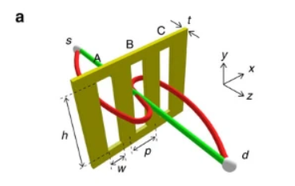Supposedly photons in a triple slit experiment can walk through one slit, walk back through the other slit, and go through the third. At least according to this paper claiming that photons can take [exotic paths.](https://www.nature.com/articles/ncomms13987) I’m pretty skeptical of this, but maybe they actually saw this. We don’t know **exactly the trajectories that these electrons take**.

The double-slit experiment does not contain the only mystery of quantum mechanics, it contains many mysteries and many unanswered questions that may become very relevant in the future!

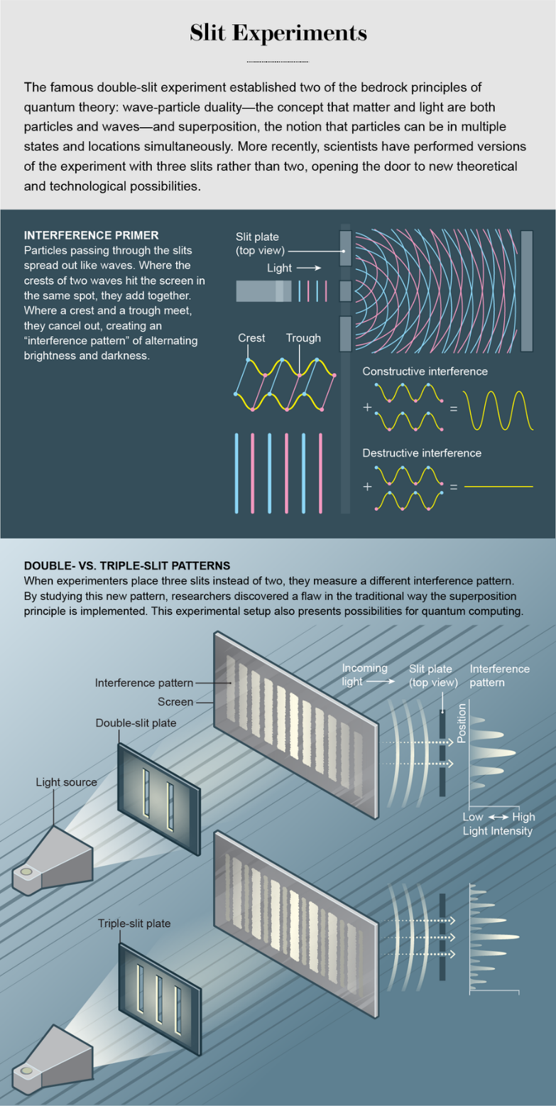Urbasi Sinha is an Indian woman who spent the last ten years exploring the double-slit experiment. She found something really interesting. Unlike what is read in textbooks, when you shine light through two holes, the superposition principle no longer applies completely. Instead, you need a correction term. In a cornfield, she did triple-slit experiments with microwaves and found that the interference pattern produced could be not be predicted by the sum of the two wave equations previously. This is because a particle could go through one slit, it could go through another slit, or it could go through both.

(12) Triple Slit Interference Pattern Investigated

There is a cool article by [Fermilab](https://www.fnal.gov/pub/science/particle-physics-101/science-matter-energy-space-time.html) which discusses what ideas scientists currently have about what everything is made of, particle physics. Everything we normally see is made of three particles, up and down quarks and electrons. There is also an electron neutrino which shoots off sometimes when an atom decays (whatever that means). There are a few other quarks, each of which is smaller than a proton, and the heaviest one having more mass than a gold atom. All the particles combine because of forces, in which these particles exchange other particles called bosons, like basketball player might pass around a basketball. Currently in the standard model of quantum mechanics, photons or light particles are what mediate electromagnetic interactions. One of my favorite quotes from physics is “We are made of stars, we are made of stardust”. It is a nice image that if we went far enough back in time, everything that 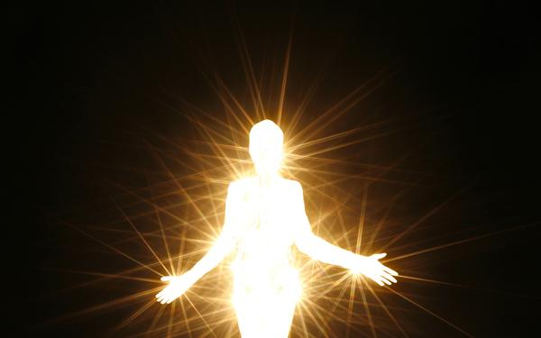makes up you and me now was once part of a star. Although space seems to go on and on and on, maybe it wasn’t always this way. Maybe we were all very close together at some point in time, like the idea of the big bang suggests. Maybe all of our stories, and the stories of the things we are made of started at the same place. Another beautiful idea is right now, maybe light is what holds my body together. In the standard model of particle physics, photons are the particles responsible for electric and magnetic interactions. Once we have all these particles, where do stars and planets and plants and animals come into the picture? Forces. In this theory forces.

Let your inner light shine - Is light what's holding my body together?

What evidence is there that light is a particle? The first piece of evidence that comes to mind is the photoelectric effect. But is assuming light is a particle the only way to explain the photo-electric effect? Well what is the photoelectric effect?

One really cheap inexpensive way to do this experiment is to take a piece of metal, place it on an “gold-leaf electroscope” which measures the amount of charge on a metal. Shining visible light on the metal does not change the charge, but shining UV light on the metal does change the charge. I watched 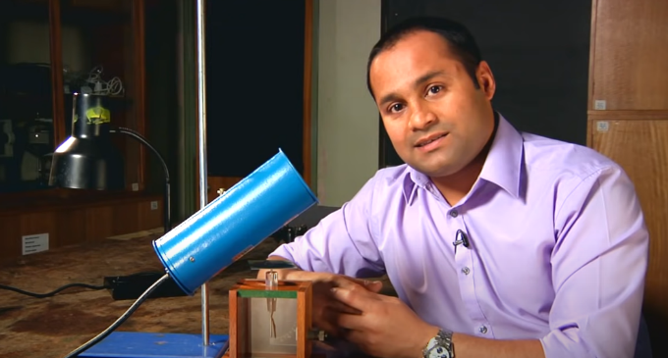this experiment live, and it finally make sense. In class I really felt like I learned “absolutely nothing”, but perhaps that’s because my “education got in the way of my learning”.

(13) Low-cost photoelectric experiment uses gold-leaf electroscope to monitor charge on metal plate

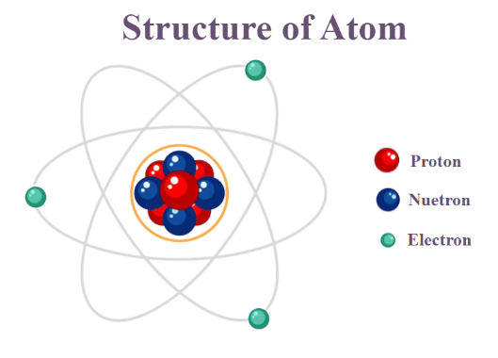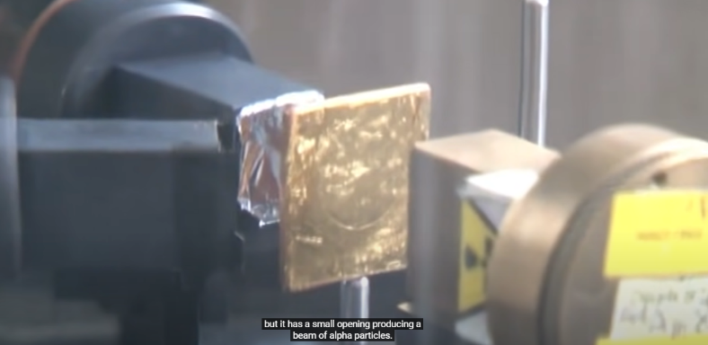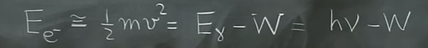Unless I see these experiments, the big ideas in physics aren’t real to me, like wave-particle duality. They are a story being shared with me, its all theoretical until I see with with my own eyes. In physics, **seeing is believing**, and I really won’t believe these conclusions unless I see it for myself. For example, would I believe that this table is mostly empty space. **How can something be full and empty at the same time?** Well maybe things that appear full are actually empty. Like for example, this room I am typing in looks like its full of solid things, desks, and chairs, and computers. But the scientific theory atoms suggests that at any given time, most of these objects are empty space. Some people interprete scientific experiments like the Rutherford Gold Foil experiment this way and develop a model of the atom that looks like this:

(15) Rutherford Gold Foil Experiment

(14) Einstein explain photoelectric effect by assuming light comes in bundles

However, some people this that this is model is too simplified, and that there are things that fill up that “empty space” like electric and magnetic fields, or even particles themselves (like Chirstopher Baird who specializes in optics they study of light, quantum cascade lasers, and electromagnetic scattering).

This particle collider is huge, and apparently the particle dectector consists of a huge solenoid magnet which bends the particles outwards.

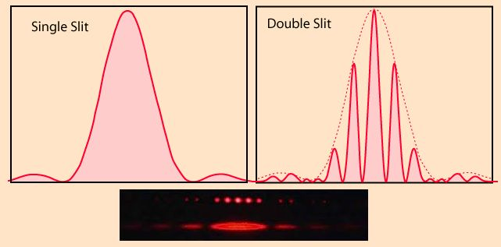It be really cool if this was a graph a could actually generate with light.

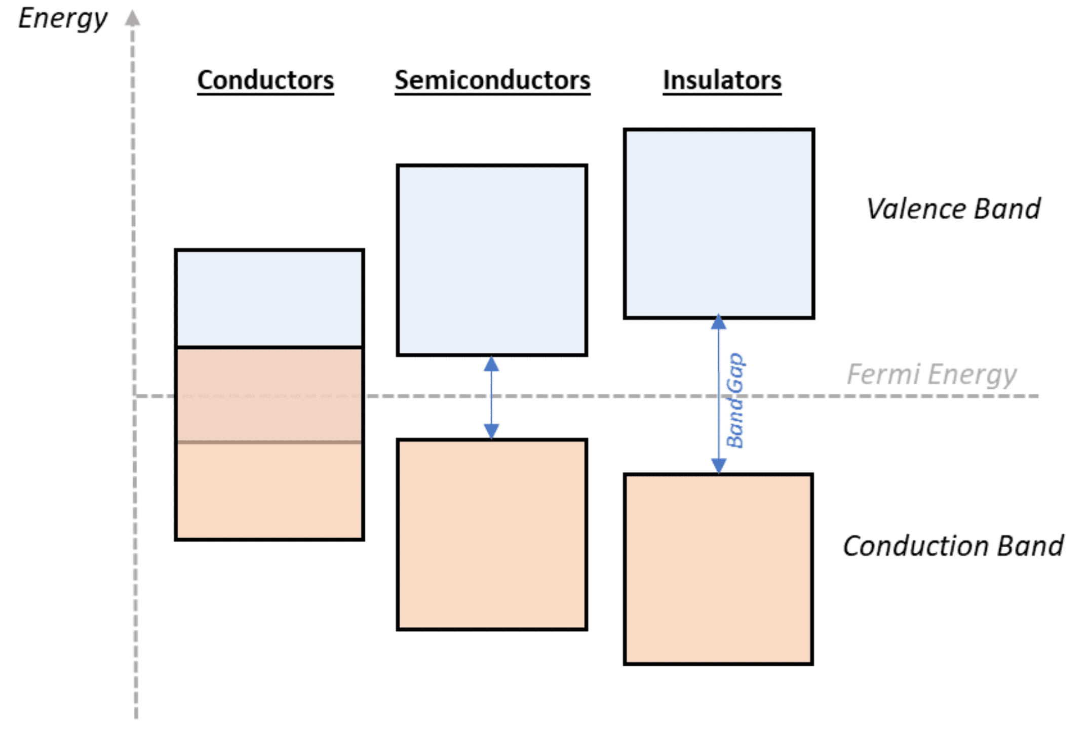The story of [light](https://www.pveducation.org/pvcdrom/materials/optical-properties-of-silicon), is also the story of matter. If the entire world was made up of light, then I could jump too the sun and across the universe lightning fast, because I would be made of light as well. I just read an interesting article about band gap, which determines how some materials like semiconductors interact with light. Semiconductor absorb wavelengths of light that have energy above the band gap, but do not absorb wavelengths of light with energy below its band gap. So what is a band gap?

Let’s start off with an idea of an atom. Everything in the universe is made up of three things, protons, neutrons, and electrons (atleast those are our names for the three things). Focusing on the electron, physicists believe electrons can sit on different levels, like a child on a staircase, and cannot exist on any other energies in between.

Atoms stick together when they share electrons, and these electrons are said to have energies in the valence band. When some atoms stick together like in a metal, some electrons are free to roam around the entire material, and these electrons are said to have energies in the conduction band.

Now if the valence and conduction bands overlap, that means we have electrons free to move around the material, and the material is a conductor. Because of these excess electrons

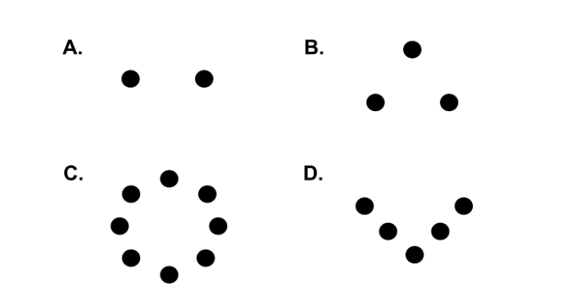It’s not just me who find this simple experiment fascinating. Somebody at Vanderbilt created lab around diffraction and interference, and they said that Feynman path integral were a very cool way to describe and predict interference patterns.

(15) Various holes arranged in patterns

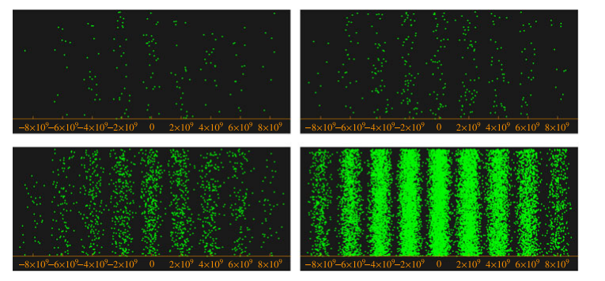Glenn Webb also finds this phenomenon really interesting and has been conducting simulations of this experiment for at least 10 years! Here is a paper from 2011 that shows the interference patterns created by a simulation of these photons:

(17) Glenn's simulation of the double slit experiment

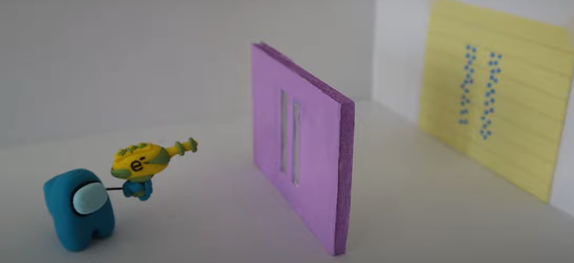I just found a super cute youtuber who makes super cute videos about physics and nerdy things in general. Her name is vt.creates, and I am in love! She made a super cute video on the double slit experiment with electrons and I just have to post it!

(18) Vt.Physics nerdy redition of double-slit

Websites Cited

1. Ask A Biologist ([ASU](https://askabiologist.asu.edu/epithelial-cells#:~:text=Take%20another%20look%20at%20your,and%20arms%20into%20many%20positions.))
2. [Digizime](https://www.digizyme.com/cst_landscapes.html) Cell Landscapes
3. [Scientific American](https://www.scientificamerican.com/article/see-the-highest-resolution-atomic-image-ever-captured/): The Highest Resolution Atomic Image Ever Captured!
4. Electron Beam [Double Slit](https://iopscience.iop.org/article/10.1088/1367-2630/15/3/033018#nj458349fig1) Experiment (2013)
5. [American Journal of Physics:](https://pubs.aip.org/aapt/ajp/article/70/3/288/1055810/Nine-formulations-of-quantum-mechanics)  9 Formulations of QM (2002)
6. [Ask A Mathematician](https://www.askamathematician.com/2020/05/q-what-if-the-particles-in-the-double-slit-experiment-were-conscious-could-you-ask-them-which-slit-they-went-through-afterwards/): Double-slit Eraser Experiment
7. [Nature Physics](https://www.nature.com/articles/s41567-019-0663-9): Molecules over 25,000 amu create inteference
8. [Scientific American](https://www.scientificamerican.com/slideshow/a-do-it-yourself-quantum-eraser/): Do it yourself Double-Slit Eraser Experiment
9. [Tomas Bohr:](https://www.youtube.com/watch?v=5TypwAwmPew&t=81s) Performing the Double-Slit Experiment with Bouncing Droplets
10. [Oak Ridge](https://web.ornl.gov/~kentpr/thesis/pkthnode11.html) National Lab
11. [PBS 13: Brian Greene](https://www.youtube.com/watch?v=vyP80vLos60) Explains the Double-Slit Experiment
12. [Scientific American:](https://www.scientificamerican.com/article/quantum-slits-open-new-doors/#:~:text=In%20the%20experiment%2C%20first%20proposed,of%20light%20interspersed%20with%20darkness.) Quantum Slits Open New Doors
13. [National STEM](https://www.youtube.com/watch?v=v-1zjdUTu0o) Centre: Demonstration of photoelectric effect
14. [MIT Opencourseware](https://www.youtube.com/watch?v=byEaU9ILHmw): Lecture on photoelectric effect
15. Rutherford Gold Foil Experiment
16. [Vanderbilt University](https://cdn.vanderbilt.edu/vu-my/wp-content/uploads/sites/2692/2019/04/14145219/lab10_problems.pdf) Physics Department: Lab Experiment
17. [Glenn Webb](https://link.springer.com/article/10.1007/s10773-011-0866-z): Event Based Interpretation of Schrodinger’s
18. [Vt.Physics](https://www.youtube.com/watch?v=gNiSaZ3P2zo): Cool video explaining slit experiment (electrons)

Unexplored:

* [Pretty good website that explains the inference patterns and the Fraunhoffer Diffraction Formula! http://labman.phys.utk.edu/phys136core/modules/m9/interference.html](Pretty%20good%20website%20that%20explains%20the%20inference%20patterns%20and%20the%20Fraunhoffer%20Diffraction%20Formula!%20http://labman.phys.utk.edu/phys136core/modules/m9/interference.html)
* <https://hal.science/hal-00656118>
* [Waves are the way physicists describe quantum objects](https://en.wikipedia.org/wiki/Wave_function)
* [Quantum Double-Double](https://www.nature.com/articles/s41598-020-68181-1#:~:text=This%20self%20interference%20of%20a,of%20a%20photon%20gradually%20emerges.) Slit Experiment
* Video by Fermilab on Double Slit: <https://www.youtube.com/watch?v=nmxwVU88Bd8>